Collecting User Behavior Through Google Analytics

Website/SEO Assignments

NAME: Tahiya Rahman

horizontal line

# About the Data

The purpose of the paper is to find out trends in behavior for the top 10 most viewed pages collected. The data showed the top viewed pageviews and the most bounce, exit rates along with the average session time users spent on the sites. The user behavior analysis showed a decent interest in NSTEM internship page.

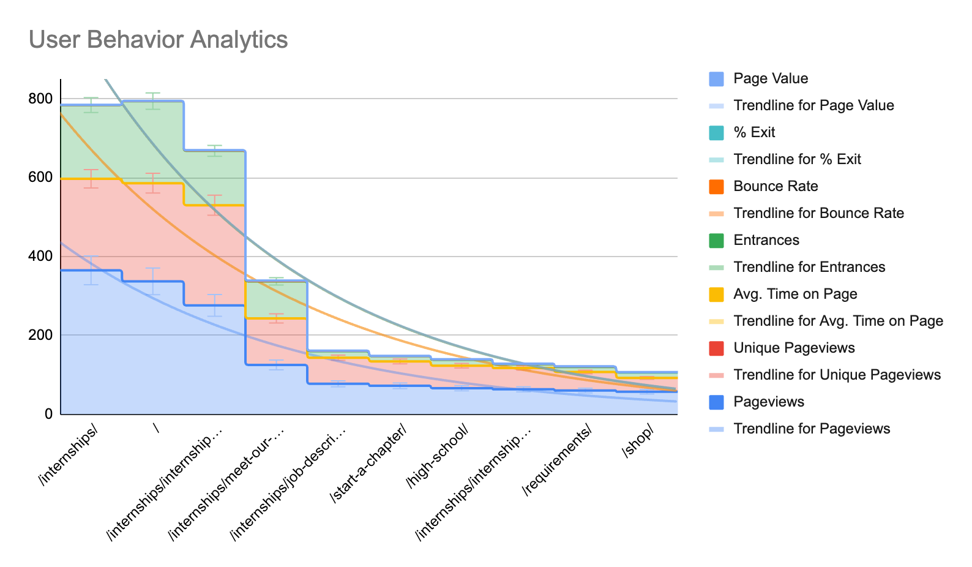

* As the data shown above, from behavior data the highest traffic generator audience **/internships** page from Pageviews, Unique pageviews, Entrance.
* The second trend is considered to be the direct sources, **/internships/meet-our-interns,** and **/internships/internship-application** from Bounce rate, Exit and average time spent.
* All the data are positioned with the trendline. Trendline considered to be the threshold level where the investment decision and a potential trend to consider as a decent source of increasing users.

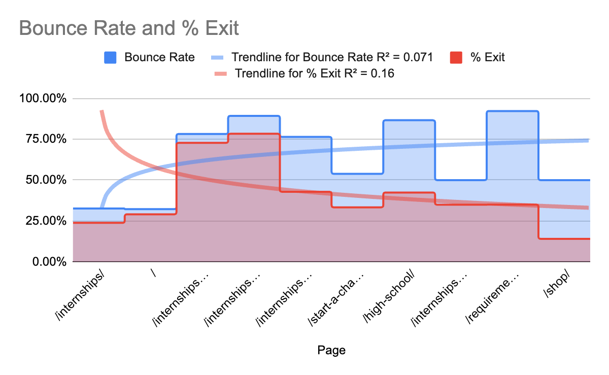

* Bounce rate and exit rate shown with the calculated R square values and also a logarithmic trendline, where the data supports for **/internships/meet-our-interns/, /internships/internship-application/ and /high-school/ and the trend hunter as /requirements/.**

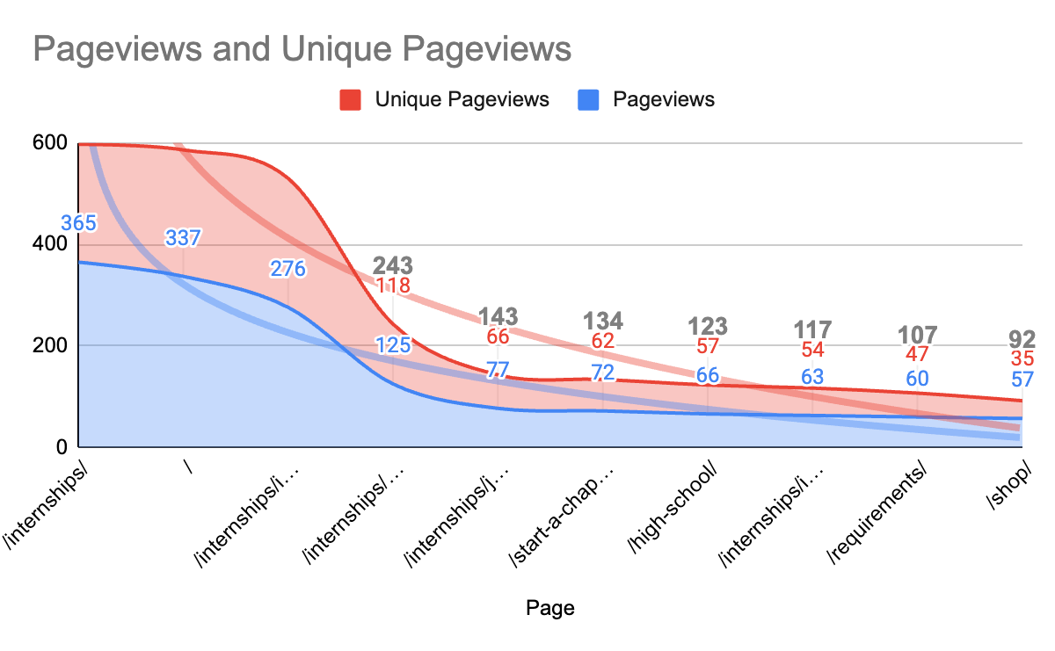

* On this trend, pageviews are generated from **/internships/** and show at a very high rate. Also generated pageviews and unique page views at an exponential rate.

# What NSTEM Should Continue Doing

* NSTEM should continue to promote internships.
* NSTEM Should make partnerships with different software companies for the internship. Because the internships page shows the highest pageviews. So there are students who are seeking internships and within employment.

# Ways to Improve the Website

* From the Days index data, NSTEM can improve the marketing and promotion strategies on the following particular day. Because the days are also counted as a factor where the users can be driven at a higher rate.

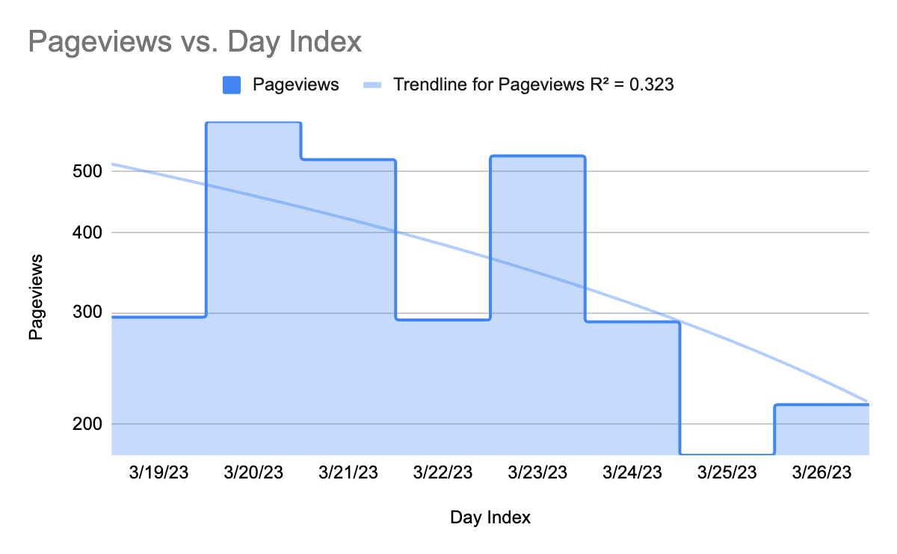

* NSTEM should create scope for hiring consultations, resume corrections and life coaches as well, student advisor, course analysis groups, workshops for the hiring opportunities.

# Data that Stands Out

From the analysis, the user behavior showed an interest towards the internship in NSTEM. NSTEM should create more visuals and a more convenient user interface for UX experience. Thus, students will be able to understand and navigate to apply for the internship easily.

# Conclusion

To conclude, the most potential trend factor was generated from the internship pages in NSTEM.

Google Sheets: <https://docs.google.com/spreadsheets/d/1l5EGAeHDcV7-NbUua9Htyn6DOOxF-TvV9eKjHQ0OXlw/edit?usp=sharing>

Google data studio: <https://lookerstudio.google.com/reporting/81e38114-3369-407d-a886-e259cdbaacb8>